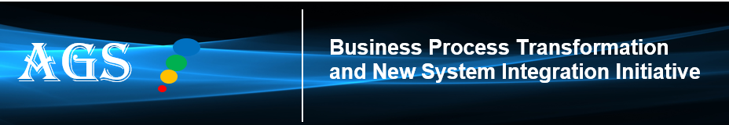
Sent to: Sales, Operations, Finance, Accounting, Procurement, Legal, Compliance, IT, Supply Chain, and other Program Stakeholders
Why am I Receiving this Newsletter?

This is an FYI awareness communication to inform you that ACG is transforming its business processes and technology structure to an industry standard model*. The intent of this communication is to inform managers and employees about the transformation, as well as provide resources to learn more.

At this moment there is no action required from you. Please see the “What’s Next” section below.

Awareness Communication
Background on the Transformation

ACG leadership recognizes our legacy business processes and technology infrastructure capabilities are limiting our production, supply chain, and sale of new products  To remain competitive, improve efficiencies, and enable new products & business models, ACG’s fragmented and siloed product data processes and systems must evolve. | 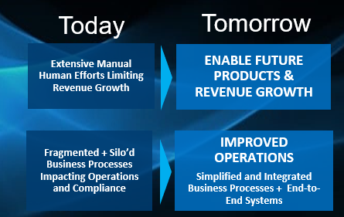
What’s Next?
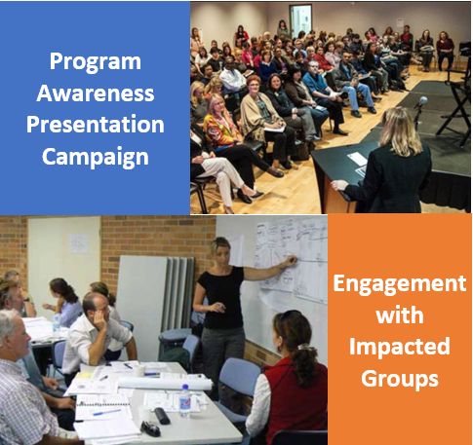 | (1) Watch out for future program communications on the progress of the program  (2) Starting in Q1 2024, we will commence meetings with organizations to present a detailed overview of the program, and to answer your questions  (3) Throughout the next 2-4 quarters we will conduct our impact assessments to determine how and when your group’s processes and solutions will be affected
For Questions / More Information
Questions?
Email the Program TCM Team or contact a member of the Program Transformation Team.
You can also contact the Subject Matter Expert, Subject Area Owner or Change Agent that is associated with your group.
Additional information? Check out our Program Transformation Site. Also check out our FAQ Page.

Next Awareness and Update Newsletter: January 2024

FAQs
For additional information, including answers to questions below, kindly visit our FAQs Page

- What are 2024 must-do objectives for the program?
- What are the new systems that will be implemented?
- What are the issues and limitations that need to be resolved?
- What are the solutions (business, technology, and others) needed to resolve these issues?
- What is the status update on the program?
- Is there a roadmap for this transformation?
- What is the scope of this transformation?

…. And many more

Subscribe I Unsubscribe

